**Monday September 8th?**

Kemi, Finland

* 20k population, recycling of textiles is common
* Misty mornings
* Football is common, finnish league
* Industrial city but tourism matters too
* Northern lights and Kemi snow castle

Finnish language belongs to the old relic

No articles, no prepositions

Glutenitive languages, add suffixes to the end of the language

Adds everything to the end of the original word

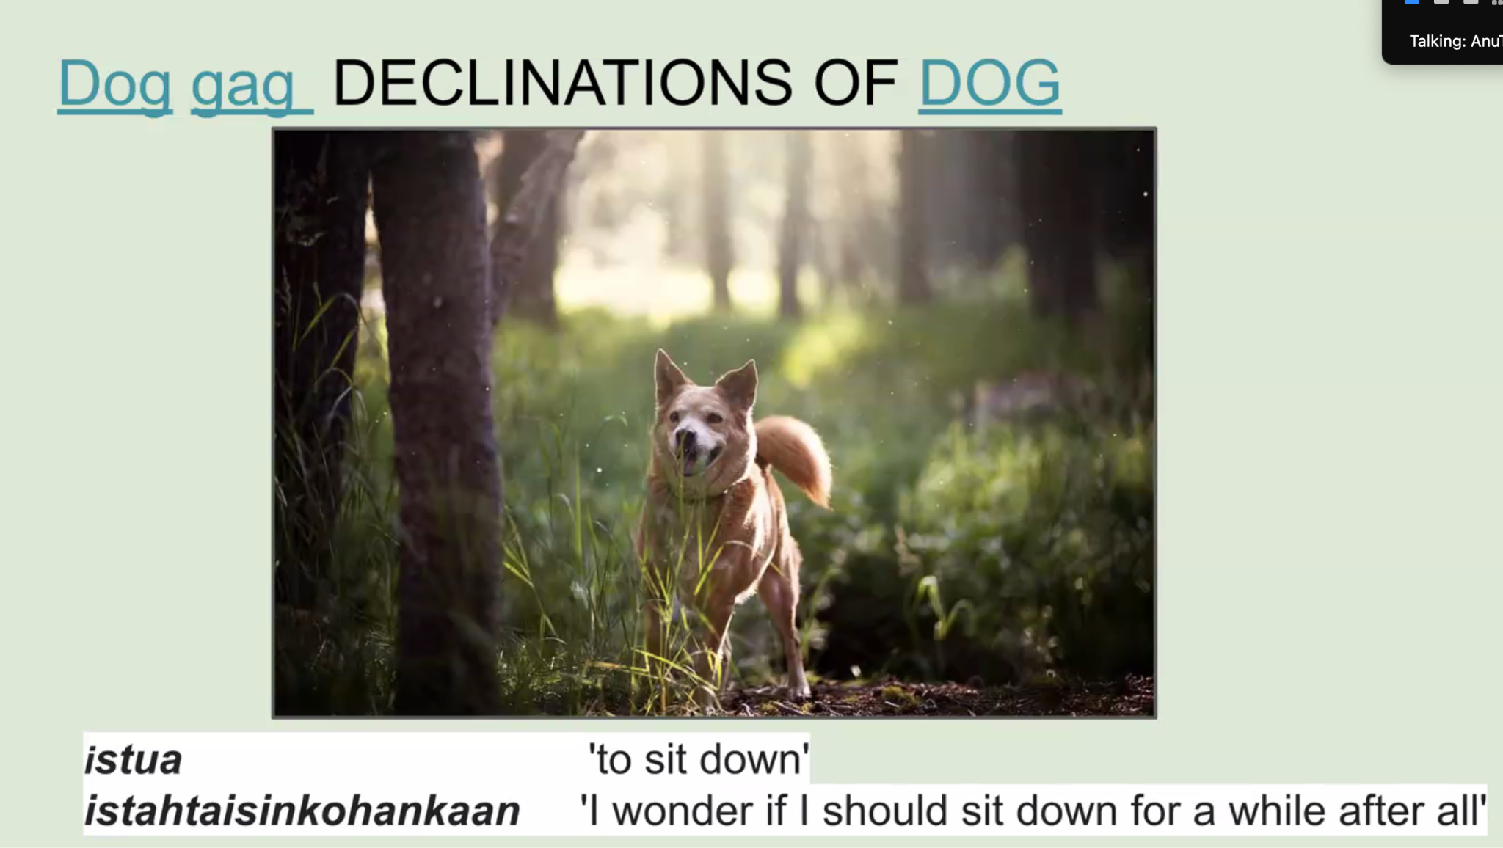

Writing system corresponds to the reading system really well

Sweden was apart of Russia for a bit 1809-1917

* We are not swedes and definitely not russians and became an independent nation

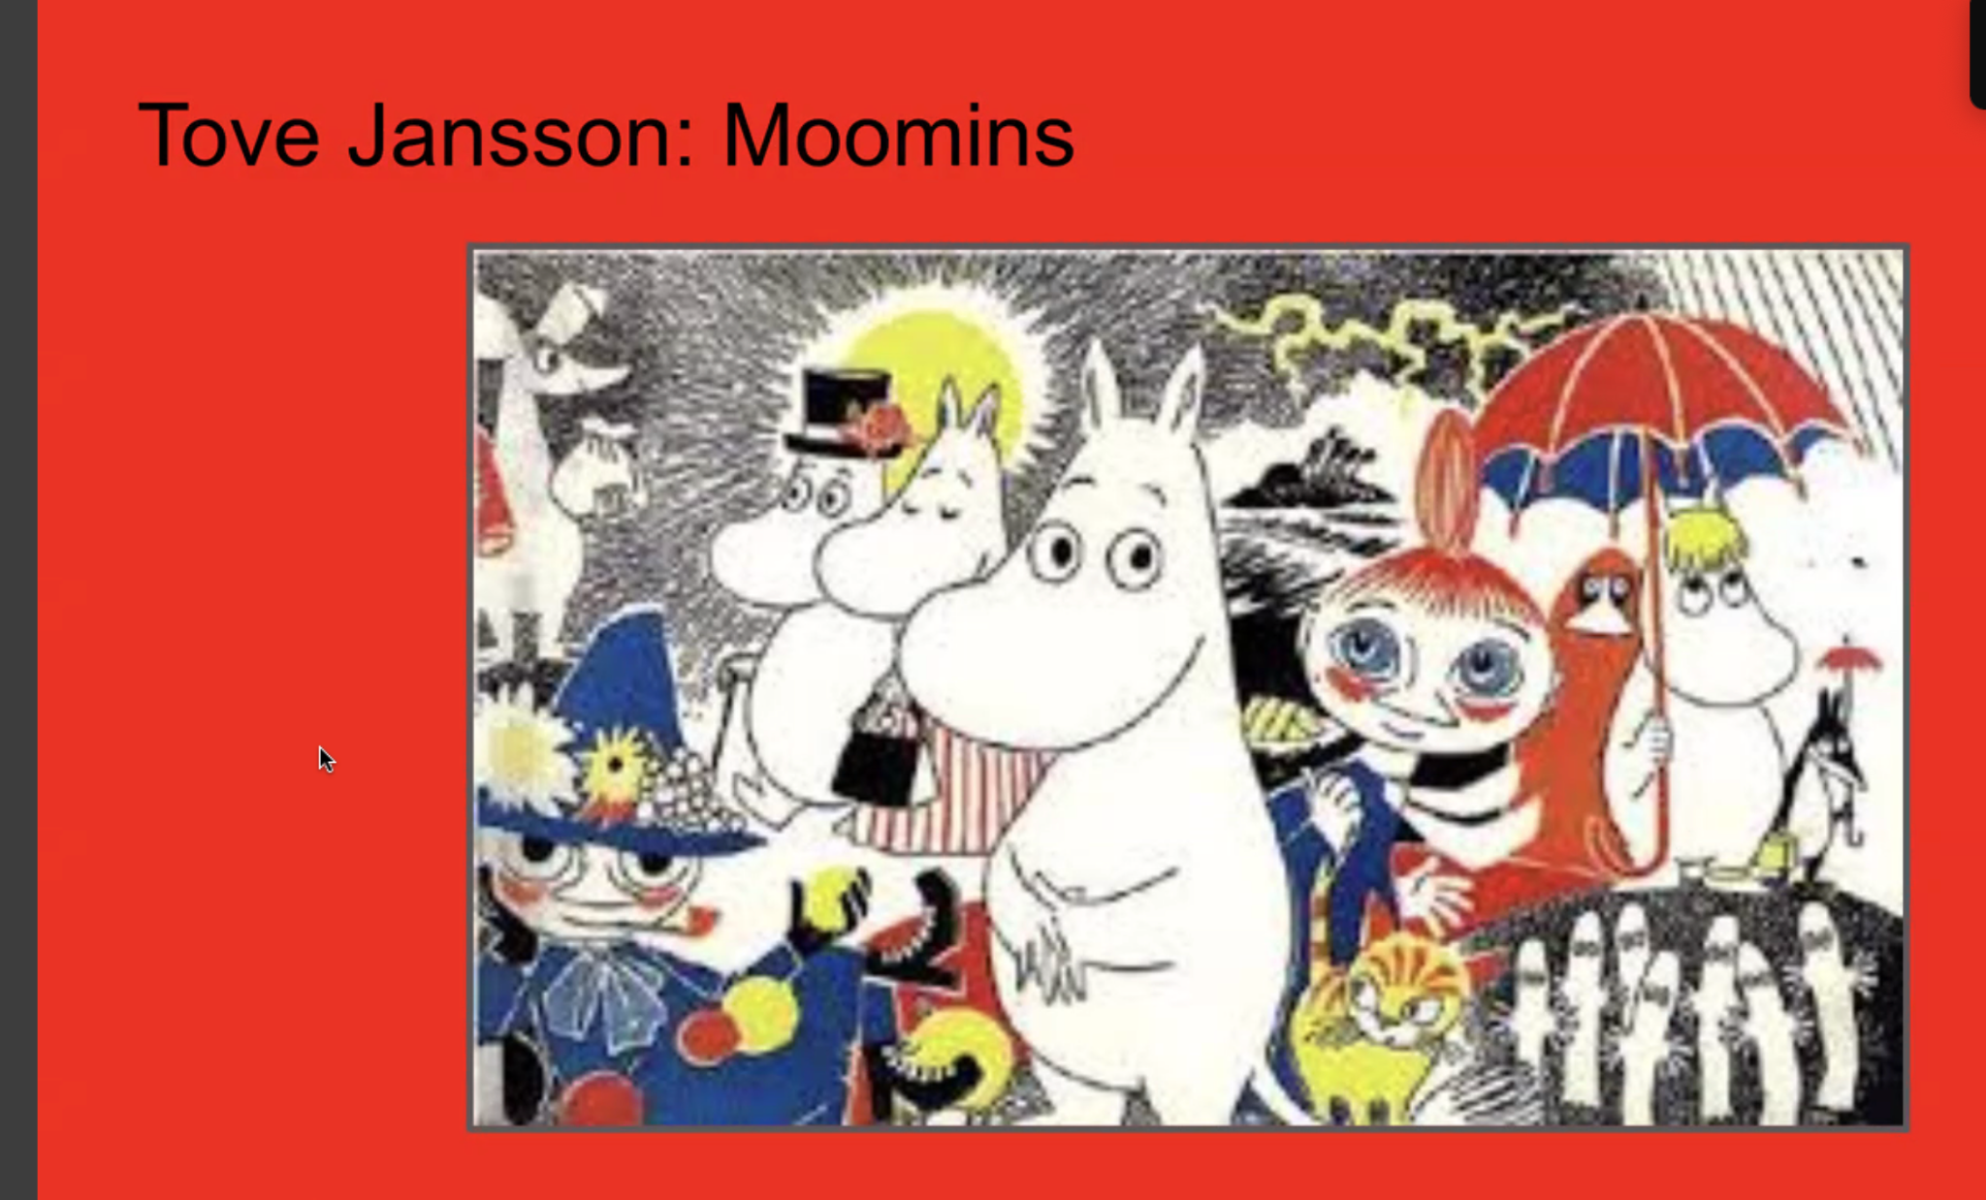

Moomins became more popular through comics and published in the UK originally. 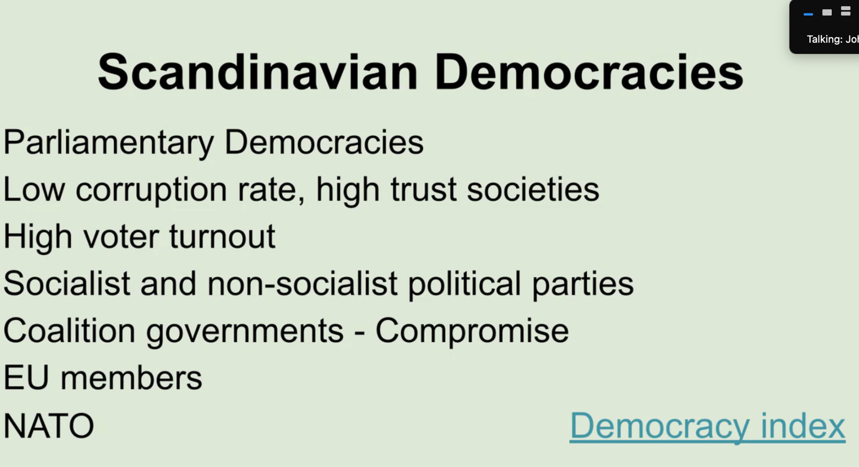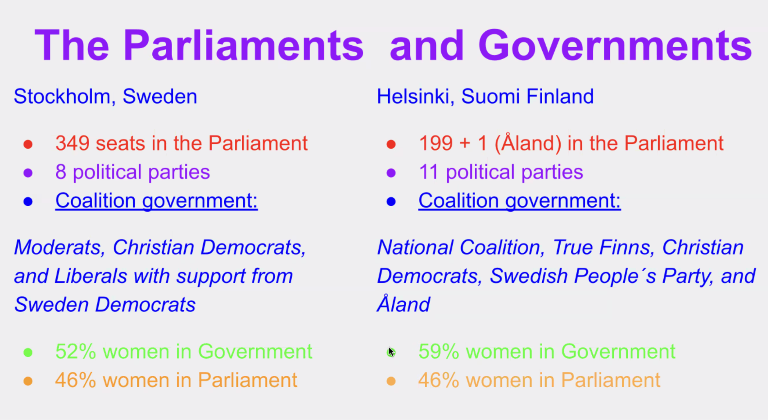

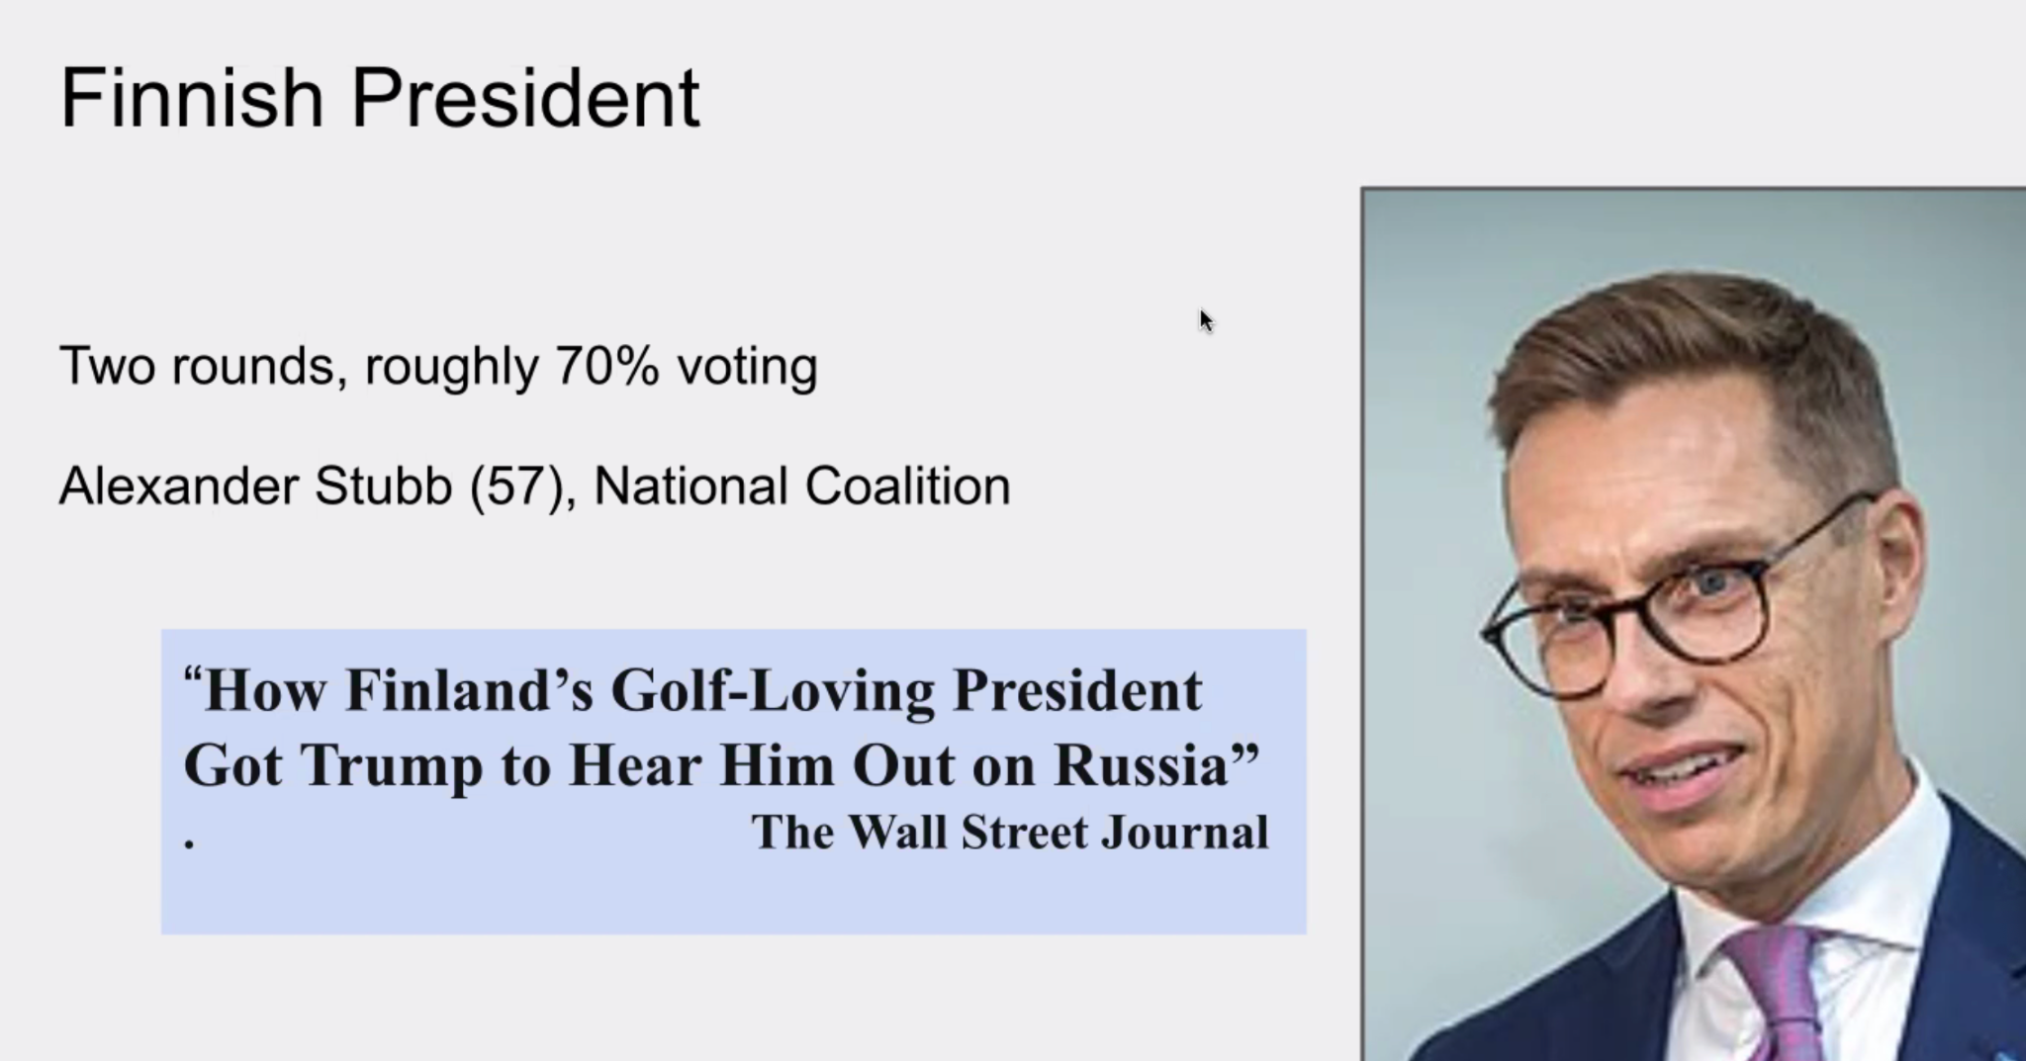

Generally policy, don’t trust Trump

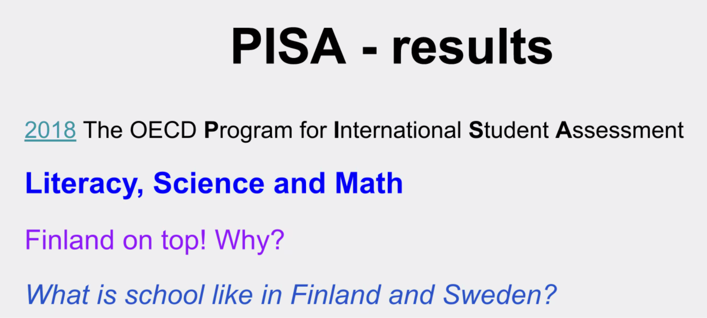

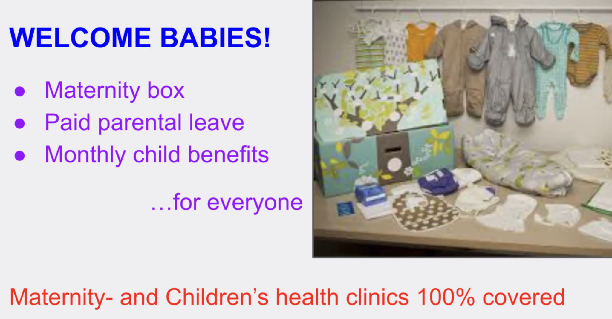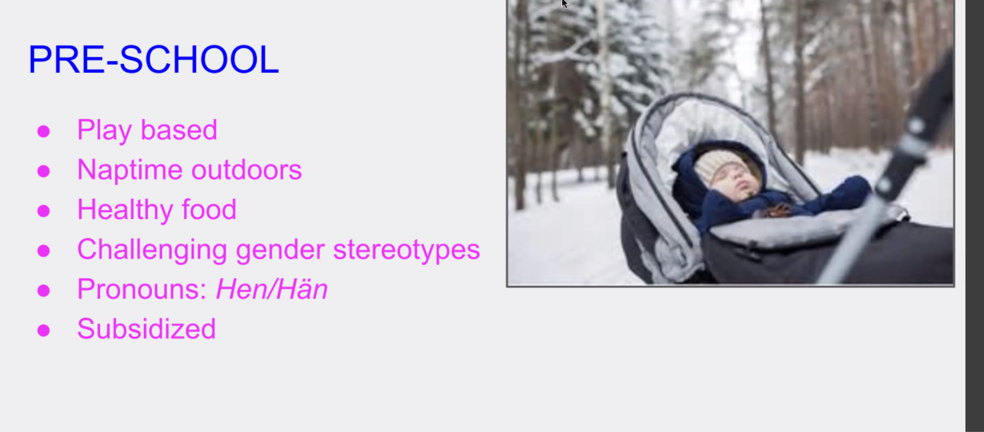

“We struggle with pronouns”, General Neutral pronouns for both he and she

